Chapter 1, Problem 7.

The charge flowing in a wire is plotted in Fig. 1.24. Sketch the corresponding current.

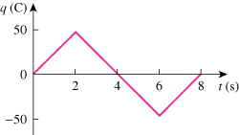

Figure 1.24
For Prob. 1.7.

